**LAB SHEET 05**

**Pehesara.A.D.**

**IT24102305**

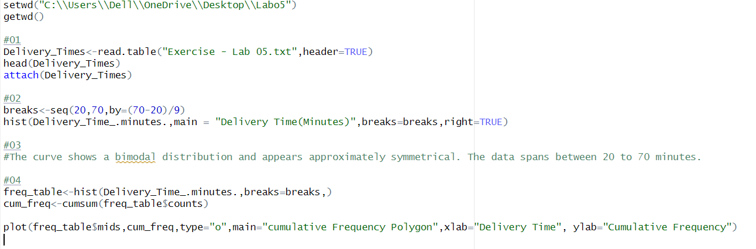

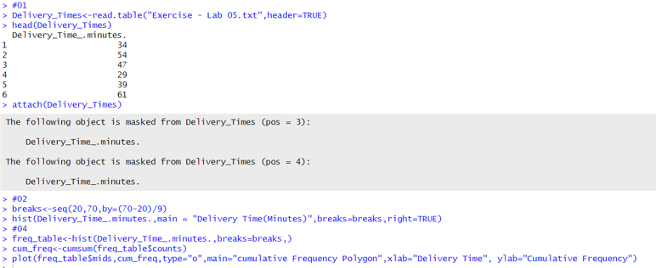

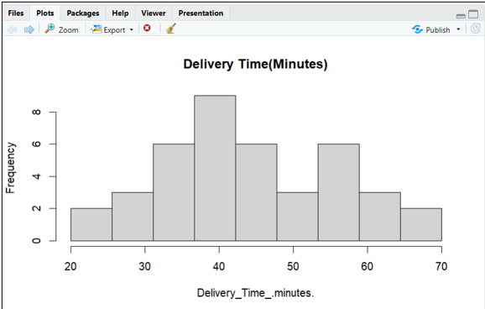

Question 03

* The curve shows a bimodal distribution and appears approximately symmetrical. The data spans between 20 to 70 minutes.

